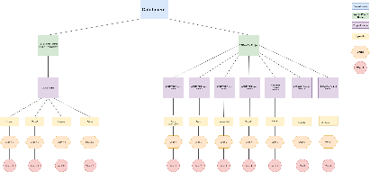

**Cox’s Bazar District WASH Programme”**

**Asrayon Project**

Sadar

Ramu

Kutubdia

Pekua

Teknaf

Moheshkhali

Chakaria

Union X

Ward X

Sadar_XX

Union X

Ward X

Ramu_XX

Union X

Ward X

Moheshkhali_XX

Union X

Ward X

Teknaf_XX

Union X

Ward X

Pekua_XX

Union X

Ward X

Kutubdia_XX

Union X

Ward X

Chakaria_XX

**COXB WASH**

Ukhiya

Ramu

Kutubdia

Pekua

Teknaf

Moheshkhali

Chakaria

Union X

Ward X

Union X

Ward X

Union X

Ward X

Union X

Ward X

Union X

Ward X

Union X

Ward X

Union X

Ward X

Sadar

Union X

Ward X

WARD X

WARD X

WARD X

WARD X

WARD X

WARD X

WARD X